SKILL-10
- To Retrieve Current Directory, Display Path, Process Exit Requests, Cleanup Resources, Save State, Verify Correct Behavior.
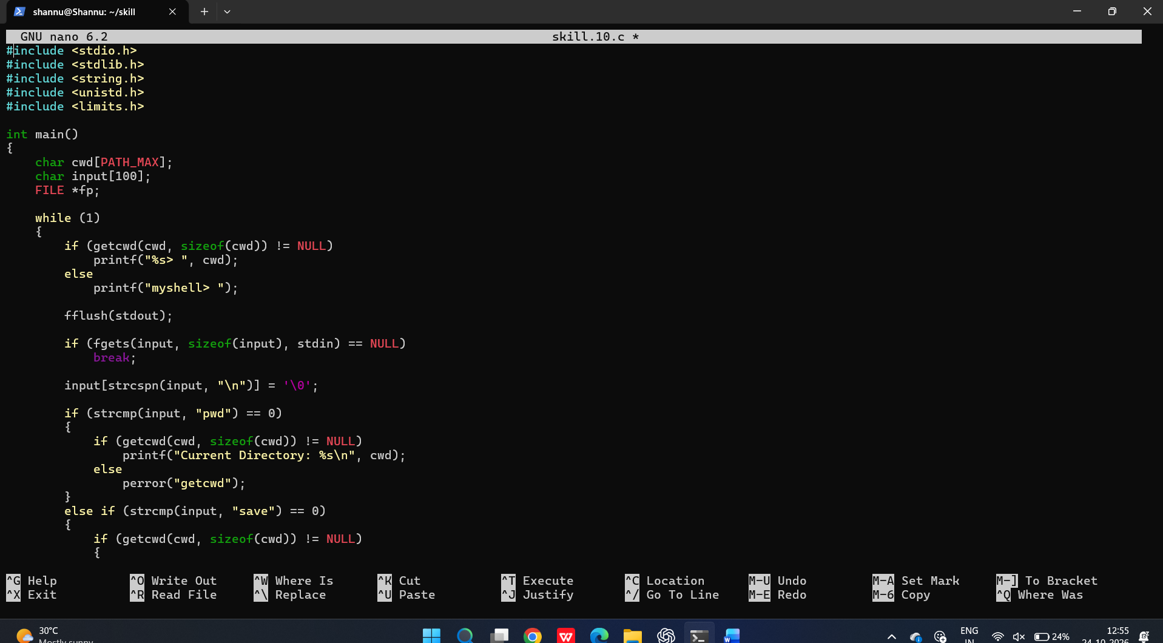
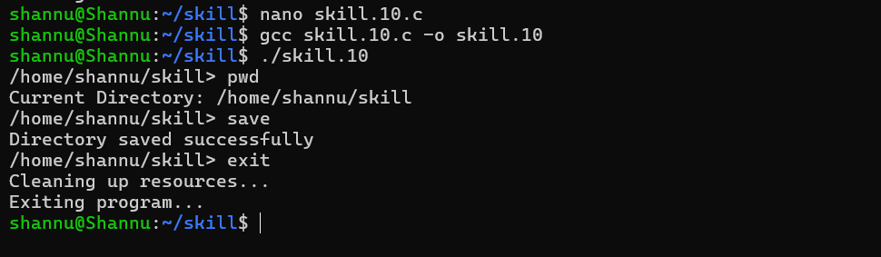

To Parse Export Syntax, Update Environment Variables, Validate Names, Handle Existing Variables, Export to Child Processes, Test Functionality.
